

FICO® Score Open Access for Credit and Financial Counseling
Program Sign-up Application and Requirements Questionnaire
If you are an eligible counseling organization, please fill out this questionnaire as part of the signup process for the FICO® Score Open Access for Credit and Financial Counseling (C&FC) program. Once all items below have been completed and all required documents returned and approved by FICO, you will be granted access to the program materials within the FICO® Score Open Access Community. Please note that the approval process may take several days.

Qualification Requirements
- In order to participate in the FICO® Score Open Access for C&FC program, a credit or financial counseling organization must meet ALL of the following criteria (please mark all boxes that apply to your organization):
☐ Has a primary purpose of providing financial counseling and/or financial educational services (e.g., educational programs on money management) and not credit repair;
☐ Has an active end-user agreement with one of the three Consumer Reporting Agencies (Experian, Equifax, TransUnion) or reseller (Equifax and TransUnion) to purchase FICO® Scores for the purpose of financial counseling;
☐ Is a 501(c)(3) nonprofit organization or a government agency (or other government entity) that provides social services, or, for TransUnion customers, a nonprofit organization with 501(c)(1) status;
☐ Is not considered a “credit repair organization” as defined in the Credit Repair Organizations Act;
☐ Has or will execute a signed program license agreement (PLA) with FICO for the program.
Please provide a comment or question here if you do not meet any of the above so we may further evaluate your application: Click here to enter text.
- Please provide organization information:
    - Organization or Company Name: Click here to enter text
    - Contact Name/Position or Title: Click here to enter text.
    - Address: Click here to enter text.
    - Telephone/FAX: Click here to enter text.
    - Email: Click here to enter text.
    - Website: Click here to enter text.
    - Approximate number of counselors, coaches, or other professionals within your organization providing credit or financial counseling or educational services: Click here to enter text.
- From the FICO® Score Open Access for C&FC Community site, download the “Program License Agreement — FICO® Score Open Access for C&FC” document for review and completion.
    - Page one: Enter company legal entity name and main mailing address.
    - Page five (signature page): Enter company legal entity name, sign, and fill in requested information. Note: The person who signs this contract must have the authority to sign a legally binding agreement on behalf of the organization or company.
    - Scan to create a PDF of the signed PLA and return all eight pages to FICO. FICO will countersign and return the executed document via email.

- Provide to FICO your proof of nonprofit status with either a copy of your 501(c)(3) or, if a TransUnion Customer, 501(c)(1) IRS Determination Letter. (Call IRS customer service at 1-877-829-5500 to request a new copy if needed.) Alternatively, provide your EIN and screenshot of your organization’s status from the Exempt Organizations Select Check page. See Appendix for an example. If you are a government agency or other government entity that provides social services, please provide other proof of eligibility.
Comments/Questions: Click here to enter text.
- Indicate if you pull scores directly from a Consumer Reporting Agency (CRA or bureau) or through a reseller, and provide the name of your CRA or CRA-authorized reseller from which credit reports and FICO® Scores are purchased.
☐ Directly from CRA. Which CRA?
☐ Equifax ☐ Experian ☐ TransUnion
☐ Through a reseller. At which CRA is the score based? Click here to enter text.
☐ Equifax ☐ TransUnion
If you do not have an active end-user agreement with a CRA or reseller, visit the C&FC Member Community page and download Consumer Reporting Agency (CRA) Contact Information for C&FC to obtain services. Please note: Experian does not allow FICO® Scores based on Experian data purchased through resellers to be disclosed to consumers under this program. If you receive FICO® Scores from a reseller that provides FICO® Scores from two or three different bureaus, this program requires you to select and consistently use FICO® Scores from only one bureau for your financial counseling FICO® Score disclosure and list below the reseller and bureau selected.
Comments/Questions: Click here to enter text.
- Affiliations. If you belong to a member trade association or operate under a parent organization, please list those affiliations below:
☐ Credit Builders Alliance (CBA) ☐ National Association of Certified Credit Counselors (NACCC)
☐ Diversified Resource Network (DRN). ☐ National Foundation for Credit Counseling (NFCC)
☐ Other: Click here to enter text. ☐ National Homeownership Resource Center (NHRC)
Scan all documents listed below separately, labeling each file with your organization’s name, and submit the completed documents to the following email address: ML_OpenAccessCFC@fico.com
- Program Sign-up Application and Requirements Questionnaire (this document)
- Program License Agreement — FICO® Score Open Access for C&FC (ALL pages)
- IRS 501(c)(3) or 501(c)(1) (TransUnion only) Determination Letter or screen shot from IRS EO Selection Check page showing your organization’s status
- Supporting documents, if you are an eligible social services provider, nongovernmental, or government entity
- Any other supporting documents or attachments related to eligibility determination
Any questions or concerns can be sent to the above email address.
- Once your organization has been determined to be eligible for the program, an email will be sent to the email address you provided with instructions on how to access the general FICO Web Community and the FICO® Score Open Access for C&FC Member Community.
Thank you for your interest in providing important FICO® Score information and education to your customers. We are confident you will find the program a worthwhile addition to your counseling and coaching toolbox with benefits for your organization, your counselors, and, most importantly, your customers in need.
Appendix - Example Exempt Organizations Select Check

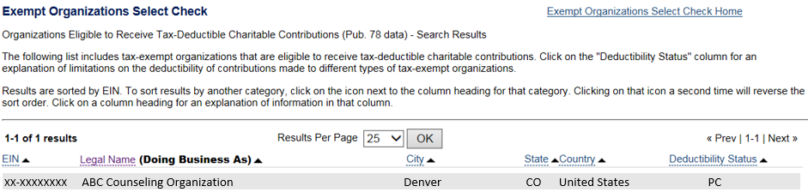

The IRS page with the Exempt Organization Select Check tool is located at this URL: https://apps.irs.gov/app/eos/
y

